**Title:** ChatBot for Java Language Query

**Group Name:** Group 07

**Team Leader:**

 Dr K Senathipathi

**Team Members**

* Dr. K.Senathipathi
* Ms.M.Kavitha
* Mr. Kumara Raja
* Mrs. G.Bhavani

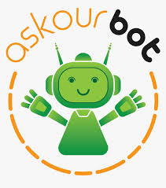

**Abstract**

Nowadays almost 30 percent of the tasks are fulfilled by chatbots. Lot of organization use the chatbots to provide services like customer support, generating information, etc. With examples like Siri, Alexa it becomes clear how a chatbot can make a difference in our daily lives. The proposed chatbot assist programmers with structures with which they can build a new applications. However, this tool apply to a fixed set of use cases and can be used to assemble and deploy a single-task bot which, at the end of the day, and ongoing management capabilities. In the past, methods for constructing chatbot architectures have relied on hand-written rules and templates or simple statistical methods. With the rise of deep learning these models were quickly replaced by end-to-end trainable neural networks around 2015. More specifically, the recurrent encoder-decoder model dominates the task of conversational modelling. This architecture was adapted from the neural machine translation domain, where it performs extremely well. The proposed chatbot will be developed by considering all the requirements of how a chatbot should response for the query. Proposed chatbot provides Quick answers to simple questions,Getting 24-hour service, Quick answers to complex questions,Ability to easily register a complaint,Getting detailed / expert answers, etc.,

**Table of Contents**

1. Introduction

a. Introduction to Wipro

b. Introduction to Project

1. Objective of the project
2. Project Modules (like Frontend , Backend)
3. Flow of the execution (include flow chart, if any),
4. Output screen shot
5. Summary
6. Key Challenges
7. Conclusions and Recommendations (if any)
8. Bibliography
9. References
10. Glossary

**Chapter - 1**

**INTRODUCTION**

**1.1 INTRODUCTION TO WIPRO**

Wipro Limited is an Indian [multinational corporation](https://en.wikipedia.org/wiki/Multinational_corporation) that provides [information technology](https://en.wikipedia.org/wiki/Information_technology), consulting and business process services. It is headquartered in [Bangalore](https://en.wikipedia.org/wiki/Bangalore), [Karnataka](https://en.wikipedia.org/wiki/Karnataka), [India](https://en.wikipedia.org/wiki/India). In 2013, Wipro separated its non-IT businesses and formed the privately owned [Wipro Enterprises](https://en.wikipedia.org/wiki/Wipro_Enterprises).Wipro has shifted to Work from Anywhere model since March 2020. Building open-domain chatbots is a challenging area for machine learning research. While prior work has shown that scaling neural models in the number of parameters and the size of the data they are trained on gives improved results, we show that other ingredients are important for a high-performing chatbot. Artificial Intelligence Markup Language (AIML) is derived from Extensible Markup Language (XML) which is used to build up conversational agent (chatbot) artificially. Wipro developed a lot of works to make a conversational agent. But the low ececost, configuration and availability make possible to use it in various applications. In this case, they are not only providing useful services but also interact with customers and give solution of their problems through AIML chatbot instead of human beings. So, this is popular day by day with entrepreneur and users to provide efficient service. Good conversation requires a number of skills that an expert conversationalist blends in a seamless way: providing engaging talking points and listening to their partners, and displaying knowledge, empathy and personality appropriately while maintaining a consistent persona. We show that large scale models can learn these skills when given appropriate training data and choice of generation strategy. Human evaluations show our best models are superior to existing approaches in multi-turn dialogue in terms of engagingness and humanness measurements.

A conversational agent (chatbot) is a piece of software that is able to communicate with humans using natural language. Modelling conversation is an important task in natural language processing and artificial intelligence (AI). Indeed, ever since the birth of AI, creating a good chatbot remains one of the field’s hardest challenges. While chatbots can be used for various tasks, in general, they have to understand users’ utterances and provide responses that are relevant to the problem at hand. Since then a multitude of variations [Serban et al., 2016] and features was presented that augment the quality of the conversation that chatbots are capable of. More specifically, I feed additional features into the model like mood or persona together with the raw conversation data. Finally, I conduct a detailed analysis of how the vanilla model performs on conversational data by comparing it to previous chatbot models and how the additional features, affect the quality of the generated responses.

**1.2 INTRODUCTION TO PROJECT**

In Training Strategy We consider two training strategies to learn a multilingual conversational model: multilingual training and cross-lingual training. Multilingual Training jointly learns to perform personalized conversations in multiple languages. We follow a transfer learning approach by initializing our models with the weights of the large multilingual pre-trained model M-Bert. For the causal decoder, we add the causal mask into the self-attention layer to convert the M-Bert encoder to the decoder. For the encoder-decoder model, we randomly initialize the cross encoder-decoder attention. Then, we train both models on the combined training set in all 7 languages using cross-entropy loss. Cross-lingual Training transfers knowledge from the source language data to the target languages. In this setting, the model is trained in English (source language) conversational samples and evaluated on the other 6 languages. We align the embedded representations of different languages into the same embedding space by applying cross-lingual pre-training to the encoder-decoder model. In this project , we give a brief review of some applications which are used chatbot for their conversational service. These applications are related to cultural heritage, e-learning, e-government, web base model, dialogue model, semantic analysis framework, interaction framework, humorist expert, network management, adaptive modular architecture as well. AI chatbots are a hot commodity right now and they constitute a fertile area of research for machine learning. Researchers from all over the globe are working hard to push the envelope for what we can expect from chatbots.

Personalized dialogue agents have been shown efficient in conducting a human-like conversation. This progress has been catalyzed thanks to an existing conversational dataset such as Persona-chat. However, the training data are provided in a single language and thus the resulting systems can perform conversations only in the training language. For wide, commercial dialogue systems are required to handle a large number of languages since the smart home devices market is increasingly international therefore, creating multilingual conversational benchmarks is essential, yet challenging since it is costly to perform human annotation of data in all languages. A possible solution is to use translation systems before and after the model inference, a two-step translation from any language to English and from English to any language. This comes with three major problems: 1) amplification of translation errors since the current dialogue systems are far from perfect, especially with noisy input; 2) the three-stage pipeline system is significantly slower in terms of inference speed; and 3) high translation costs since the current state-of-the-art models, especially in low resources languages, are only available using costly APIs.

**Chapter - 2**

**OBJECTIVE OF THE PROJECT**

Nowadays companies are trying to keep up with the upcoming trends in technology. With innovative technologies, numerous activities of the organization are getting simpler and moderate. Chatbots are one of these, embraced by practically all organizations these days.

The main purpose of chatbots is to strengthen customer relations with the company. Chatbots offer personalization and scalability in maintaining customer engagement.

Some of the benefits of chatbots are:

**Customer support** - Normally bots are used for answering customer queries. Bots could be trained for answering simple questions of customers on their own like "location of the company", "career email id", etc. If the query of a customer is not generic then it can also be transferred to a human agent.

**Accessibility -** Chatbots can answer the queries of customers 24 hours and all 365 days, while this couldn't be possible through customer service employees.

**The large volume of requests** - Chatbots can process a large volume of requests from customers. It can answer many customers at the same time without delay.

**Maintenance** - The maintenance cost of chatbots is much low. Once it's been implemented in the system, you don't need to have after-sales service for it from time to time.

Thus, Chatbots streamline interaction between people and services and enhances customer experience. It provides an opportunity to improve customer engagement.

The creation of chatbots has become much easier nowadays and it's completely hassle-free.

**Chapter - 2**

**PROJECT MODULES**

1. Preparing the Input: Intents.json
2. Question and Answer System.
3. Plugins/Components.
4. Natural Language Processing: NLTK

**Preparing Bag of words:**

def bag_of_words(s,words):

bag=[0 for _ in range(len(words))]

s_words = nltk.word_tokenize(s)

s_words = [stemmer.stem(word.lower()) for word in s_words]

for se in s_words:

for i,w, in enumerate(words):

if w == se:

bag[i]=1

return numpy.array(bag)

**Training the Model using NN**

import tflearn

from tflearn.layers.core import input_data, dropout, fully_connected

from tensorflow.python.framework import ops

ops.reset_default_graph()

net = tflearn.input_data(shape=[None,len(training[0])])

net = tflearn.fully_connected(net,8)

net = tflearn.fully_connected(net,8)

net = tflearn.fully_connected(net,len(output[8]),activation="softmax")

net = tflearn.regression(net)

model = tflearn.DNN(net)

model.fit(training,output,n_epoch=1000,batch_size=8,show_metric=True)

model.save("model.tflearn")

**Flow of the execution**

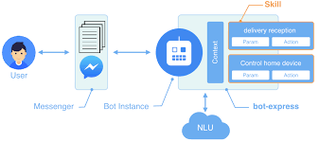

ARCHITECTURE DIAGRAM

**OUTPUT SCREEN SHOT**

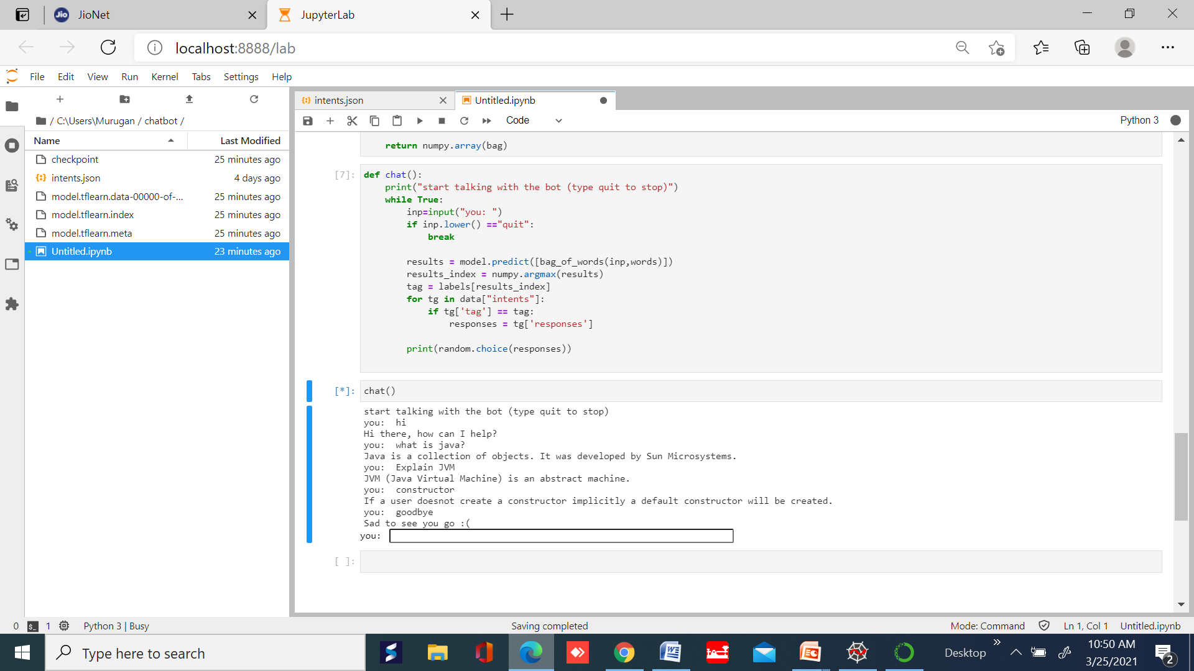

**Intents.json file**

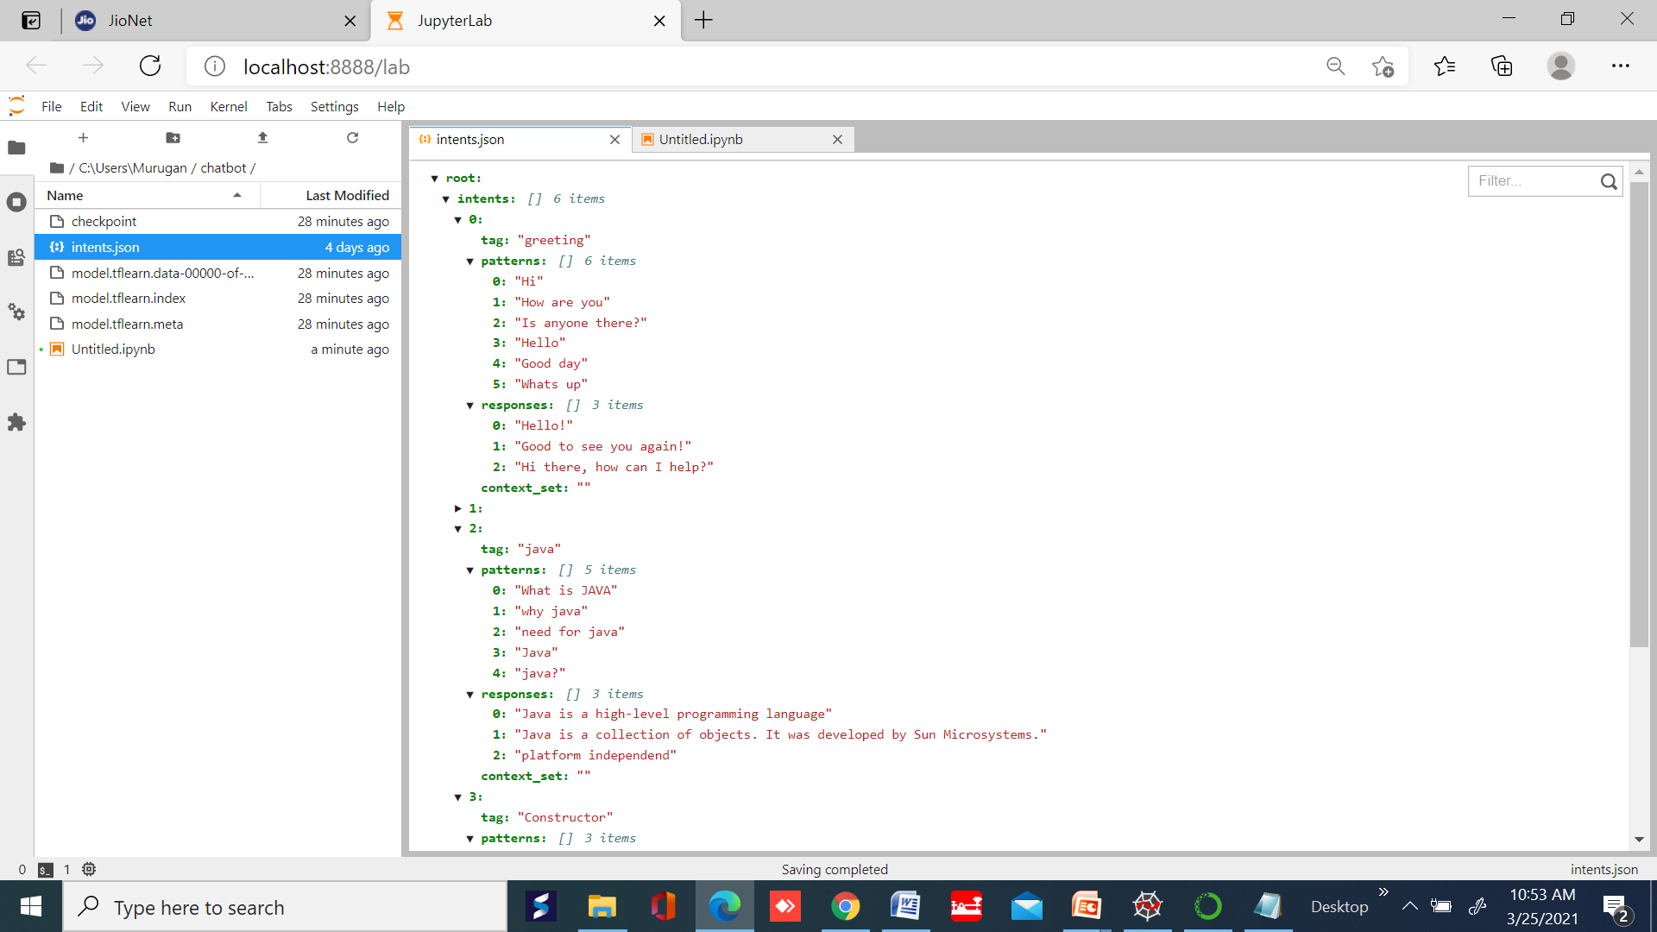

**SUMMARY**

Communication has been the essence of life from the beginning of times. With the evolution of technology, mode, and style of communication have also evolved. In the early days, conversations were restricted to verbal and textual interaction between humans. These interactions are usually guided by emotions, context, and awareness of the previous conversation. With the advent of computers, interactions have now expanded to include machines i.e. human-machine interactions. The transition from a command-based interface to a Graphical User Interface (GUI) to a Conversational User Interface (CUI) was natural, need-based and this transition made the communication easier. With CUI, came chatbots that interact with users in a natural language. Further enhancements using Artificial Intelligence and NLP capabilities enabled a chatbot to understand user utterance in the natural language; derive the task from the user utterance as well as extract the information required to successfully execute the task. AI-driven, NLP-based chatbots and voice assistants are the latest in technology and a must for all businesses these days.

**KEY CHALLENGES**

For many marketers, artificial intelligence (AI) chatbots have now become an integral part of their customer care arsenal. Why? Because they enable brands to offer customers a seamless experience, fast responses, and 24/7 support. However, chatbots are not perfect. All automated chatbot systems have limitations that, if not managed, could lead to problems for your business. One of the major challenges with the use of AI chatbots is security - consumers want to trust that if they share their data with your chatbots, you will only use it to complete their transactions or offer personalized experiences. Your chatbot should therefore only ask for relevant data, and it should also have systems in place to protect this data from malicious individuals looking to mishandle or misuse it. These include virus protection, firewalls, and strong passwords.

Another challenge is the ability to make your chatbot likeable, or help it understand human emotions - if your chatbot delays or offers unhelpful responses, the customer may leave your website and may never return. Additionally, if the chatbot fails to understand user emotion, it can lead to horrible customer experiences. But there are also important benefits. To provide more context, check out this infographic, which provides a full overview of the various considerations in developing an effective chatbot, and the pitfalls to avoid.

**CONCLUSIONS AND RECOMMENDATIONS**

This project further provided both cross-lingual and multilingual baselines and compared them with the monolingual approach and two-stage translation approach. Extensive automatic evaluation and human evaluation were conducted to examine the models’ performance. The experimental results showed that multilingual trained models, with a single model across multiple languages, can outperform the twostage translation approach and is on par with monolingual models. On the other hand, the current state of-the-art achieved lower performance than other baselines. In future work, we plan to research a more advanced crosslingual generation approach and construct a mixedlanguage conversational benchmark for evaluating multilingual systems

**BIBLIOGRAPHY**

1. Designing Voice User Interfaces: Principles of Conversational Experiences - By Cathy Pearl
2. Bot Business 101: How to start, run & grow your Bot / AI business - By Ekim Kaya
3. Designing Bots: Creating Conversational Experiences - By Amir Shevat
4. Conversational Interfaces: Principles of Successful Bots, Chatbots & Messaging Apps - By Mariya Yao

**REFERENCES**

1. A. Augello, G. Pilato, A. Machi, and S. Gaglio, “An Approach to Enhance Chatbot Semantic Power and Maintainability: Experinces Within The FRASI Project,” Proc. of 2012 IEEE Sixth International conference on Semantic Computing, 2012, pp. 186-193, doi:10.1109/ICSC.2012.26
2. H. Al-Zubaide and A. A. Issa, “OntBot: Ontology Based Chatbot,”Proc. IEEE of 2011 Fourth International Symposium on Innovation in Information & Communication Technology (ISIICT), 2011, pp. 7-12, doi:10.1109/ISIICT.2011.6149594.
3. C. Erdogan, H. Nusret Bulus, and B. Diri, “Analyzing The Performance Differences Between Pattern Matching and Compressed Pattern Matching on Texts,” Proc. IEEE of 2013 International Conference on Electronics, Computer and Computation (ICECCO) 2013, pp. 135-138, doi:10.1109/ICECCO.2013.6718247.
4. J. P. McIntire, L. K. McIntire, and P. R. Havig, “Methods for Chatbot Detection in Distributed Text-Based Communications,” Proc. IEEE of 2010 International Symposium on Collaborative Technologies and Systems (CTS), 2010, pp. 463-472, doi:10.1109/CTS.2010.5478478.
5. Y. Wu, G. Wang, W. Li, and Z. Li, “Automatic Chatbot Knowledge Acquisition from Online Forum via Rough Set and nsembleLearning,” Proc. IEEE of 2008 IFIP International Conference onNetwork and Parallel Computing, 2008, pp. 242-246,doi:10.1109/NPC.2008.24.
6. S. Ghose and J. J. Barua, “Toward The Implementation of A Topic Specific Dialogue Based Natural Language Chatbot As An Undergraduate Advisor,” Proc. IEEE of 2013 International Conference on Informatics, Electronics & Vision (ICIEV), 2013, pp. 1-5, doi:10.1109/ICIEV.2013.6572650.
7. A. Augello, M. Scriminaci, S. Gaglio, and G. Pilato, “A Modular Framework for Versatile Conversational Agent Building,” Proc. IEEE of 2011 International Conference on Complex, Intelligent and Software Intensive Systems (CISIS), 2011, pp. 577-582, doi:10.1109/CISIS.2011.95.
8. G. Pilato, A. Augello, and S. Gaglio, “A Modular Architecture for Adaptive Chatbots,” Proc. IEEE of 2011 Fifth IEEE International Conference on Semantic Computing (ICSC), 2011, pp. 177-180, doi:10.1109/ICSC.2011.68.
9. G. Neubig, “NLP Programming Tutorial 2 – Bigram Language Models,” Presentation Module of Nara Institute of Science and Technology (NAIST).
10. M. Dickinson, “Smoothing,” Presentation Module of Dept. of Linguistics, Indiana University, Fall 2009.
11. Y. Bin, P. Cunlin, and L. Dan, “Chinese Text Feature Extraction Method Based on Bigram,” Proc. IEEE of 2013 International Communications, Circuits and Systems (ICCCAS), 2013, pp. 342- 346, doi: 10.1109/ICCCAS.2013.6765352

**GLOSSARY**

Artificial intelligence

Artificial intelligence (AI) is an umbrella term. It covers a wide range of technologies, which all aim to mimic human intelligence. Some chatbots use AI to better mimic human-like conversation. These chatbots are often referred to as AI chatbots.

Channel

A channel is where your chatbot lives. Any program/medium that enables two-way conversations can become a home for a chatbot. For example, a live chat channel, social media, or SMS. In chatbot terminology, you can use ‘channel’ and ‘platform’ interchangeably.

Chatbot

It would be remiss to not mention chatbots in a chatbot terminology handbook. So, a chatbot is a computer program that you can chat with. You can interact with chatbots via text-based input, or in some cases, your voice.

Compulsory input

Compulsory input is the chatbot terminology for any pieces of information that a user must provide. Without this information, the conversation cannot progress. For example, think order tracking numbers, flight information, appointment times, etcetera.

Conversational UI

A conversational user interface – or CUI – is a digital interface that seeks to allow you to engage with a program in the same way you would with a human. Rather than searching through a static interface for information, you can interact with it to ask questions. You’re conversing, rather than clicking.

Decision trees

A decision tree is a diagram that maps out the pathways to a decision. In the context of chatbots, decision trees are a map or flowchart of possible conversations. Some chatbots work using decision trees, following each step of the flow chart until the chat is over.

Entity

An entity is a variable within your message to a chatbot that helps it determine what you want it to do or say in response. For example, if you ask a chatbot what the weather will be like in London on Wednesday, both ‘London’ and ‘Wednesday’ are entities. They tell the bot that you’re asking for something specific, not for a general answer.

Flow-based

‘Flow-based’ is chatbot terminology that categorises a chatbot based on how it works. A flow-based chatbot is one that works using a decision-tree. That is, a pre-mapped-out conversation.

Hybrid chat

Hybrid chat refers to a mode of chat in which bot support blends together with human support in a smooth tag-team effort. A hybrid bot can also work as an assistant for human agents, by running admin tasks in the background.

Intent

Intent is chatbot terminology for the motive behind a user’s message. An easy way to remember it is as shorthand for intention. It’s the reason the user has messaged the chatbot — what they intend to get out of the interaction.

Intent-based

This brings us to intent-based chatbots. Intent-based chatbots work by detecting the intent of the user. It does this by recognising entities within the message. This way, the chatbot can align its response with the motive of the user.

Machine learning

A subset of AI, machine learning (ML) is the ability of a machine to learn new information and improve its output over time. As chatbot terminology, it relates specifically to machine learning chatbots. These are chatbots equipped with machine learning, that can improve their conversational ability over time.

NLP

NLP stands for natural language processing. It’s another area of artificial intelligence. NLP focuses on allowing machines (such as chatbots) to understand natural language. (Language use as you would speak or write in daily life.)

Optional input

Unlike compulsory input, optional input is information that a chatbot user can choose to provide. It isn’t crucial to the conversation. Optional input acts as a filter that can narrow the response of a chatbot down to better suit the user’s situation.

Robo-advisor

A robo-advisor is a buzzword for a specialist breed of chatbot that advises customers on a specific niche topic. For instance, a claims chatbots that parses customer claim requests.

Sentiment analysis

Sentiment analysis is the ability of a computer to detect the mood behind the messages a user sends. In chatbots, sentiment analysis allows bots to react to user mood. For example, a negative or angry sentiment score could trigger the bot to pass the chat to a human agent.

Utterance

‘Utterance’ is chatbot terminology for anything and everything a user sends to a chatbot. It’s also known as user input.

Video chatbot

A video chatbot is a bot with a human avatar. So, along with the ability to chat with and help your customers, it also comes complete with a digitally rendered human face/body and voice.

Voice recognition

Voice recognition is the ability of a machine to listen to and interpret vocal input from a user. So, instead of a typed message, a few chatbots can listen to a user instead.